**Complete Preludes of Hans Judenkünig, Hans Gerle and Hans Newsidler**

My second lutezine contribution brings together all the preambels or preludes and fundaments from the prints of three German lutenist/publishers Hans Judenkünig from Wien, and Hans Gerle and Hans Newsidler both from Nürnberg. Some preludes, or at least sections of them, are shared between prints of the three publishers, and Gerle also included versions of two fantasias by Francesco da Milano (Gerle no 8a & 9a), interestingly each different to and predating all the other known sources of them (one of each included here as no 8b & 9b, with the staves lined up to facilitate comparison and revealing a section absent and an extended final section in Gerle’s version). The sharing of music in this way casts some doubt on whether the three composed the preludes in their prints, although it seems possible that Judenkünig composed the 5 preambels, and that Gerle borrowed two of them. One wonders how Gerle came by the two Francesco recercars, although it is likely that he looked to Italy for his sources. The only music shared between Gerle and Newsidler is found in the very long prelude of each, which include several concordant sections. So who borrowed from who, or did both base their prelude on a pre-existing piece for lute or keyboard? A few items are also concordant with music in prints of Pierre Phalèse, and presumably Phalèse borrowed the music and transcribed it into French tablature. Some of the music here has already been published in a Lute Society edition,[1] but is included here for the sake of completeness.

The music has been transcribed from German into French tablature together with all playing indications,[2] and editorial changes are recorded in a commentary.**[3]** Each preambel in Judenkünig is accompanied in the original print by a diagram of a hand showing which left hand fingers to use for which frets, each preambel more or less confined to a particular register on the fingerboard, no 1 the 1st to 4th frets, no 2 the 2nd to 5th frets, no 3 the 3rd to 6th frets, no 4 the 4th to 7th frets, no 5 the 5th to 8th frets. Newsidler reproduced the fundaments in most of his prints (nor 1536b or 1544c), and interestingly, when *Das Erst Buch* 1544a was reprinted in 1547, he also included revised versions of preambels Newsidler no 7a and no 11a from his first print 1536a (no 7b and 11b).

**Worklist[4]**

**Hans Judenkünig Lutenist zu Wien[5]**

**1.** Judenkünig 1523, sigs. c2r-c2v *Das erst Priamell*

cf. Gerle no 1

**2.** Judenkünig 1523, sigs. d2r-d2v *Das ander Priamell*

cf. Gerle no 2a; Phalèse 1545, p. 16 *Praeludium*[6] [Gerle 2b]

**3.** Judenkünig 1523, sig. e4r *Das Drit Priamel*

**4.** Judenkünig 1523, sigs. g1r-g1v *Das fierd Priamel*

**5.** Judenkünig 1523, sig. h3r *Das fünfft Priamel*

**Hans Gerle Lutinist zu Nürnberg[7]**

**1.** Gerle 1532, sigs. L3v-L4r *Priambel*

cf. Judenkünig no 1

**2a.** Gerle 1532, sigs. N1r-N1v *Priambel*

cf. Judenkünig no 2

**2b.** Phalèse *Des Chansons Livre Premier* 1545, p. 16 *Praeludium*

**3.** Gerle 1533, ff. 3v-9r *Ein güt Priambel auff allerley Claues*

cf. Newsidler no 12 [shared sections]

**4.** Gerle 1533, f. 9r *Nochlauff auff das Priambel*

**5.** Gerle 1533, ff. 9v-10v *Priambel*

**6a.** Gerle 1533, f. 9v *Priambel*

**6b.** Phalèse 1545, p. 3 *Aliud Praeludium*

Phalèse *Des Chansons Livre Premier* 1547, sig. B1v *Praeludium*

F.IX.70 pp. 9-10 *VI Praeludium*

**7.** Gerle 1533, ff. 11r-11v *Priambel*

**8a.** Gerle 1533, ff. 11v-13v *Priambel*

**8b.** Gardano 1546 [46G2][8], sigs. D1r-D3r *Fantasia di Fran. da Milano*

Ness 5: s.d., ff. 5r-6v *Recercar*; 36S1, ff. 8v-11r *B* [header: *Recercata di Francesco da Milanese.*];[9] 36S2, ff. 12v-15r *A* [header: *Recercata di Francesco da Milanese.*]; 36S2, ff. 34v-37r *B* [header: *Recercata di Francesco da Milanese.*]; 36M, ff. 4v-6r *Recercar*; 61G2, sigs. D1r-D3r *8 Fantasia di Fran. da Milano*; 63S2, pp. 25-29 *Fantasia di F. da M.*; 68Plt, ff. 7v-8r *Fantasia*; 86SK, sigs. A2r-A3v *FANTASIA. III*; F-Pn Rés 429, ff. 64r-68r *Recer: zimlich Mediocre* [header: *recercata di francesco milanese*]; IRL-Dm Z.3.2.13 (Marsh), pp. 173-175 [untitled] (Gregory no 3);[10] NL-DHnmi Kluis A 20 (Siena), ff. 23r-23v [untitled]; S-Uu Vok.mus.hs 87, ff. 61r-61v *Ricerca di franco damilano*.

**9a.** Gerle 1546 [46HG], sigs. a1v-a2r *Priambel*

**9b.** Gardano 1546 [46G2], sigs. C4r-C4v *Fantesia di F. da Milano*

Ness 3: s.d, ff. 3v-4v *Recercar*; 36S1, ff. 7r-8r *A* [header: *Recercata di Francesco da Milanese.*];[11] 36S2, ff. 11v-12r *R* [header: *Recercata di Francesco da Milanese.*]; 36S2, ff. 25r-26r *R* [header: *Recercata di Francesco da Milanese*]; 56H, pp. 211-214 *Ein sehr lieblich[e] Fantasey durch Wolff Heckel*; 61G2, sigs C4r-C4v *7 Fantesia di Fran. da Milano*; 63S2, pp. 23-24 *Fantasia di F. da M.*; F-Pn Rés 429, ff. 57v-59r *Recercata* [header: *recercata di francesco milanese*]; IRL-Dm Z.3.2.13 (Marsh), p. 94 *fansy by frans Mylla* (Gregory no 14); GB-NO Mi LM 16 (Willoughby), ff. 8r-9r *ff*[antasia] (Gregory no 13); US-NHub Mus.13 (Braye), ff. 16r-17r *A fantazia fraucis de Myllane* (Gregory no 2).

**Hans Newsidler Burger zu Nürnberg [12]**

**1.** Newsidler 1536a, sigs. d1r-diiir *Nun volgt ein anders fundament das vil kunstreycher ist aber ein wenig schwerer dann das erst*

Newsidler 1544b, sig. D1r -Diiir *Nun volgt ein anders fundament das vil kunstreycher ist aber ein wenig schwerer dann das erst*

Newsidler 1549, sigs. div-diir *Nun volgt ein anders fundament das vil kunstreycher ist aber ein wenig schwerer dann das erst*

**2.** Newsidler 1536a, sig. c3r *Die Erst Regel un*d *ist ein gering fundament der Lauten / der ersten regel des geringen fundaments*; Newsidler 1536a, sigs. c4r-c4v *Das klein fundament mit dem einigen pünctlein / der ersten regel des geringen fundaments*; Newsidler 1540, sig. A2v *Das erst fundame*n*t auf die Lauten volgen Drey Regel*; Newsidler 1544a, sig. Aiir *Das Erst Fundament auff die Lauten*; Newsidler 1544b, sig. ciiir *Die Erst Regel un*d *ist ein gering fundament der Lauten*; Newsidler 1544b, sigs. c4r-c4v *Das klein fundament mit dem einigen pünctlein / der ersten regel des fundaments*; Newsidler 1547, sig. Aiir *Das Erst Fundament auff die Lauten*; Newsidler 1549, sig. ciiir *Die Erst Regel un*d *ist ein gering fundament der Lauten / der Ersten Regel des geringen fundaments*; Phalése 1545, p. 1 *Primum Fundamentum*; Newsidler 1549, sig. ciiiiv *Das klein fundament mit dem einigen pünctlein / der ersten regel des fundaments*

**3.** Newsidler 1536a, sig. c3v *Die ander Regel und ist ein ander art / der ander regel*, Newsidler 1536a, sig. c4v *Die ander Regel / der andern regel im fundament*; Newsidler 1540, sig. A3r *Die ander Regel*, Newsidler 1544a, sig. Aiiv *Die ander Regel am fundament*; Newsidler 1544b, sig. ciiiv *Die ander Regel und ist ein ander art / der ander regel*; Newsidler 1544b, sig. ciiiv *Die ander Regel und ist ein ander art / der ander regel*; Newsidler 1547, sig. /1 *Die ander Regel am fundament*; Newsidler 1549, sig. ciiiv *Die Ander Regel und ist ein ander art / der ander Regel*; Newsidler 1549, sig. d1r *Die Ander Regel / der andern Regel im fundament*

**4.** Newsidler 1536a, sig. c3v *Die drit Regel* *und ist auch eine andere art / der dritten regel des geringen fundaments*

Newsidler 1536a, sig. c4v *Die drit regel*; Newsidler 1540, sig. A3r *Die Dritt Regel*; Newsidler 1544a, sig. Aiiv *Die drit Regel / der dritten Regel*; Newsidler 1544b, sig. ciiiv *Die drit Regel und ist auch eine andere art / finis der dritten Regel des gerinden fundaments*; Newsidler 1544b, sig. ciiiiv *Die drit Regel und ist auch eine andere art / finis der dritten Regel des gerinden fundaments*; Newsidler 1547, sig. Aiiv *Die drit Regel / der dritten Regel*; Newsidler 1549, sig. ciiiv *Die Drit Regel und ist auch ein andere art /finis der Dritten Regel des gerinden fundaments*;Newsidler 1549, sig. d1r *Die Drit Regel / der Drit Regel*

**5.** Newsidler 1536a, sig. s3r *Preambel*

Newsidler 1544b, sig. Siiiv *Preambel. 53.*

**6.** Newsidler 1536a, sig. s3v *Preambel*

**7a.** Newsidler 1536a, sig. s4r *Preambel* [13]

**7b.** Newsidler 1547, sig. fir *Ein gut Preambulum. 25.*

**8.** Newsidler 1536b, sigs. A3v-A4v *i. Ein seer guter Organistischer Preambel*

**9.** Newsidler 1536b, D3v-D4v *x. Ein gut trium mit schönen fugen*

**10.** Newsidler 1536a, sig. x3r *Ein gut Preambel* 12

NL-Hgm 23.C.30, no. 1 untitled

**11a.** Newsidler 1536a, sig. s4v *Preamel*

**11b.** Newsidler 1547, sig. fiiiir *Ein gut Preambulum. 26.*

**12.** Newsidler 1536b, sigs. Aa1v-Bb3v *xli. Preambel / Hie volget ein sehr kunstreicher Preambel oder Fantasey darinn sind begriffen vil mancherley art von zwisachen und drifachen doppel laiffen auch sincupationes und vil schöner fugen durch mich Hansen Newsidler lutenisten zu samen gepracht und corrigirt.*

cf. Gerle no 3 [shared sections]

**13.** Newsidler 1549, sig. fir *Ein gut Preambl für junge Schüler 12.*

**14.** Newsidler 1549, sig. fiiiir *Volgt ein gut Preambl*

**15.** Newsidler 1549, sig. nir *Ein gut Preambel 34.*

**16.** Newsidler 1549, sigs. 9iiv-9iiir *Ein gut Preambel mit fugen 65.*

*John H. Robinson, September 2012* [14]

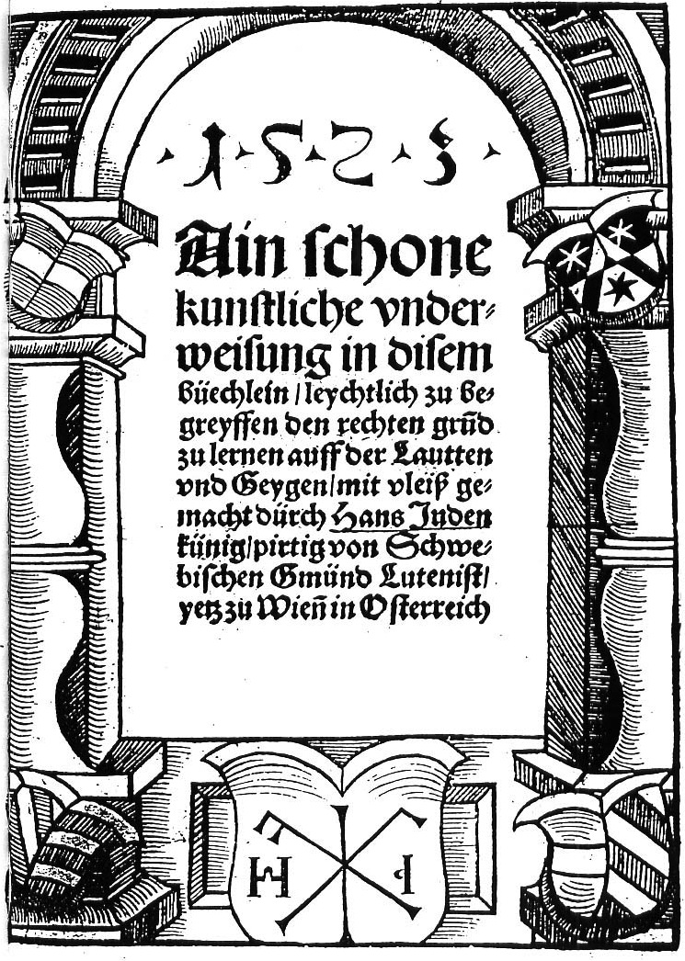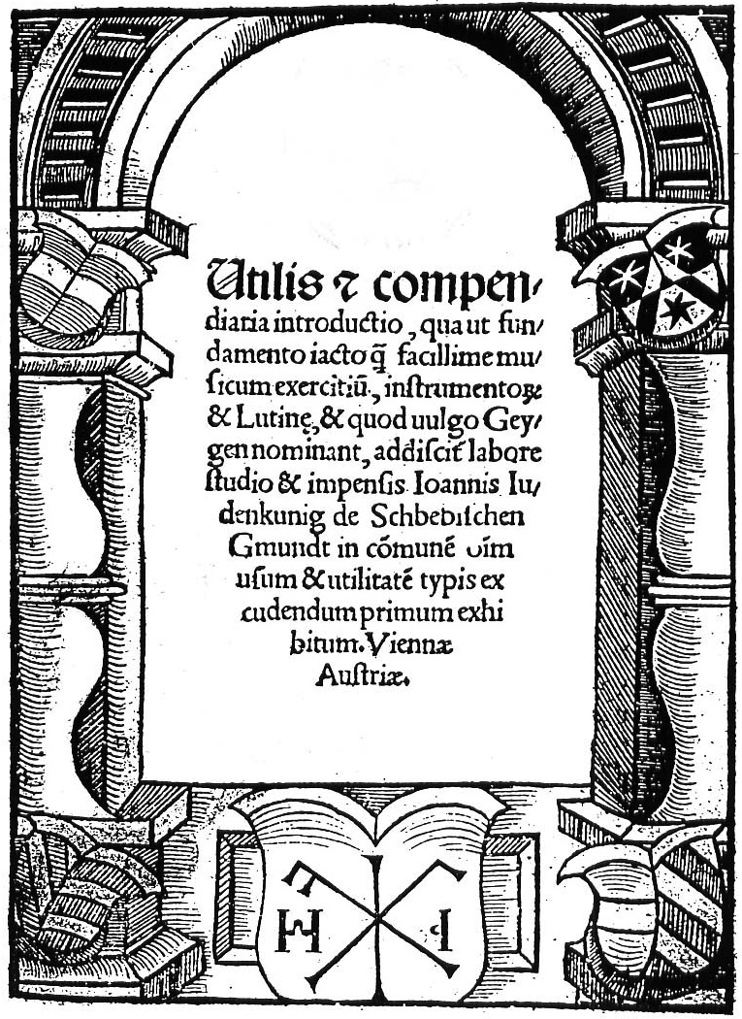

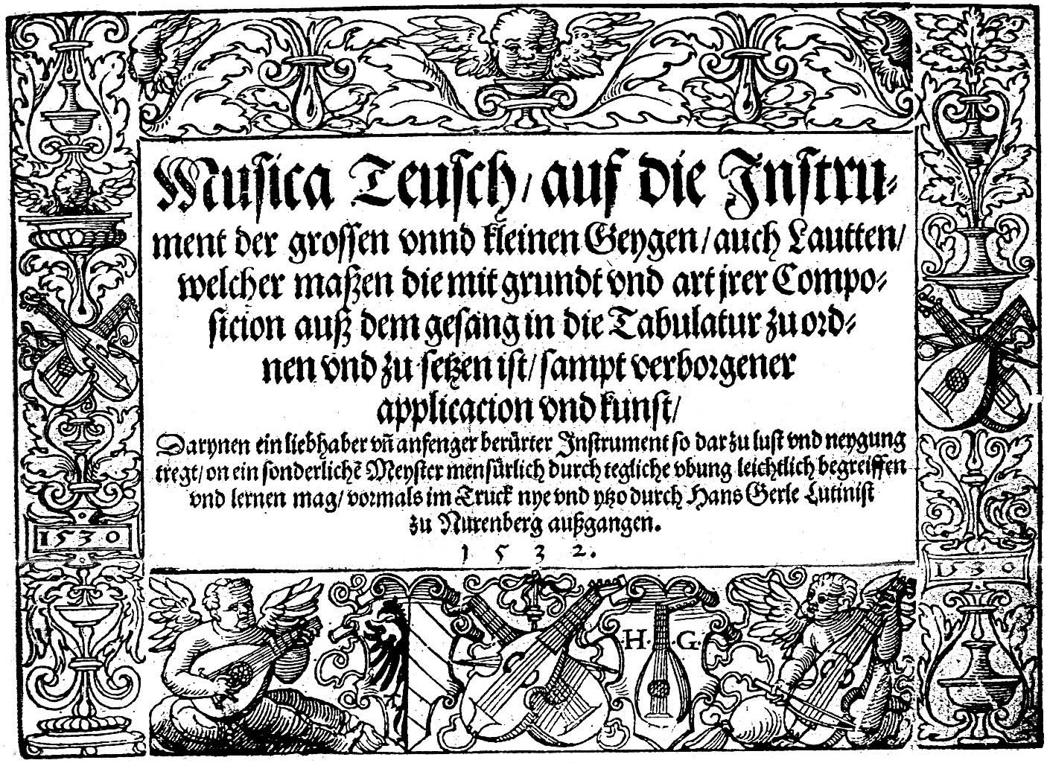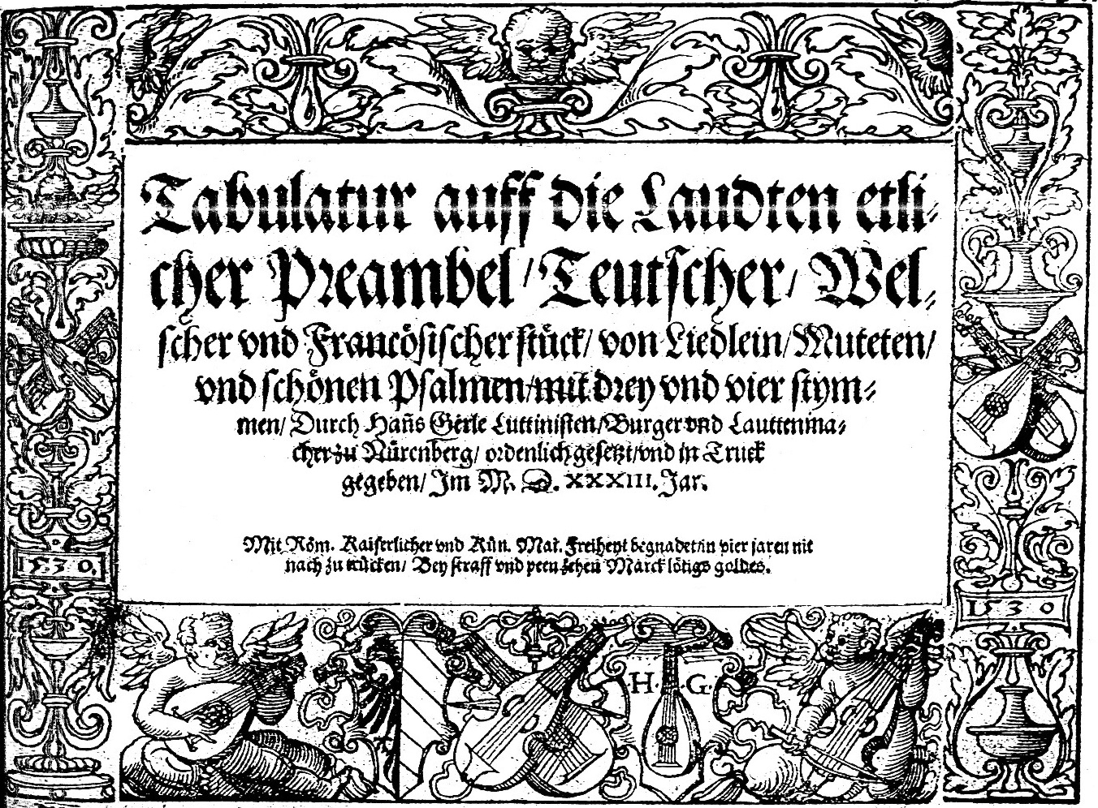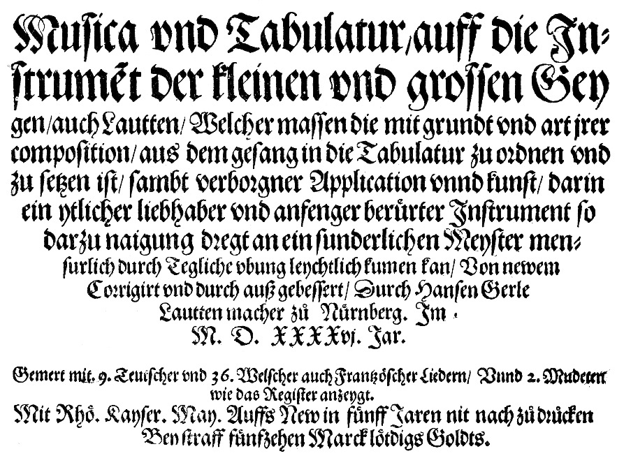

**Judenkünig 1523**

**Judenkünig c.1519**

**Gerle 1552**

**Gerle 1533**

**Gerle 1532**

**Gerle 1546**

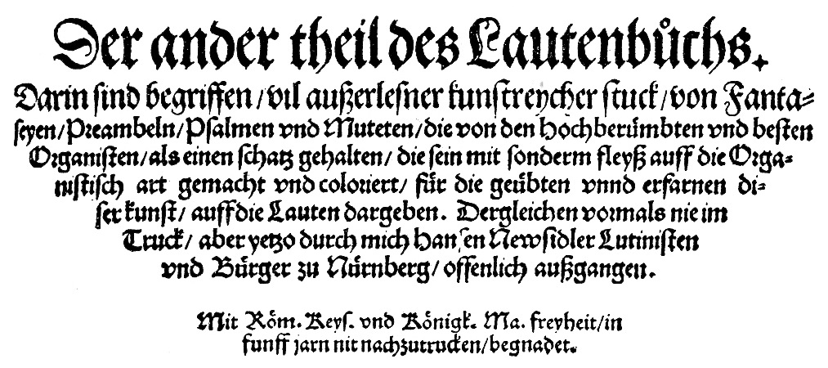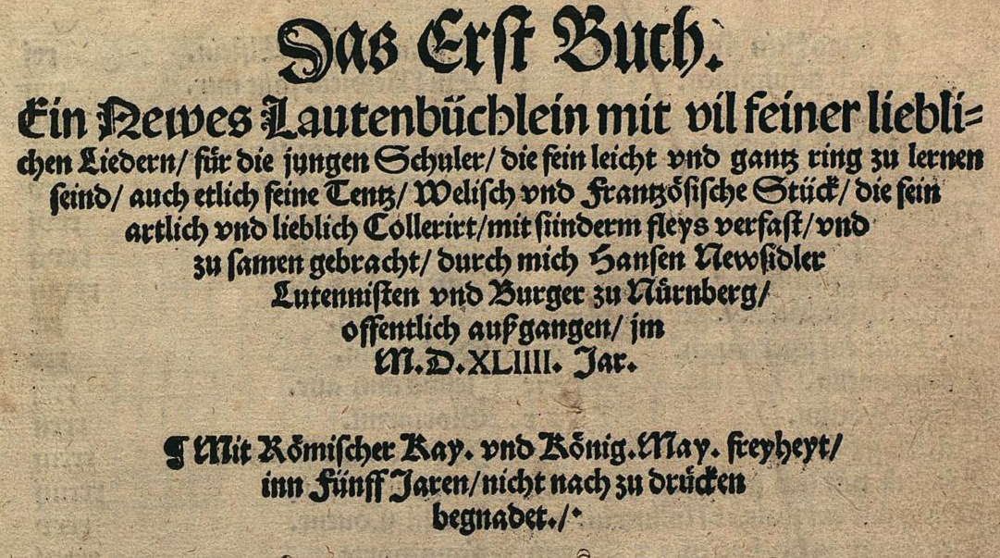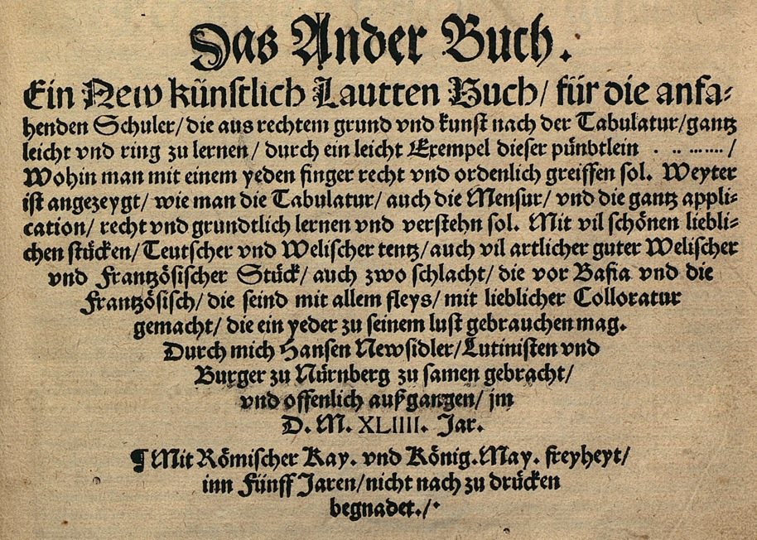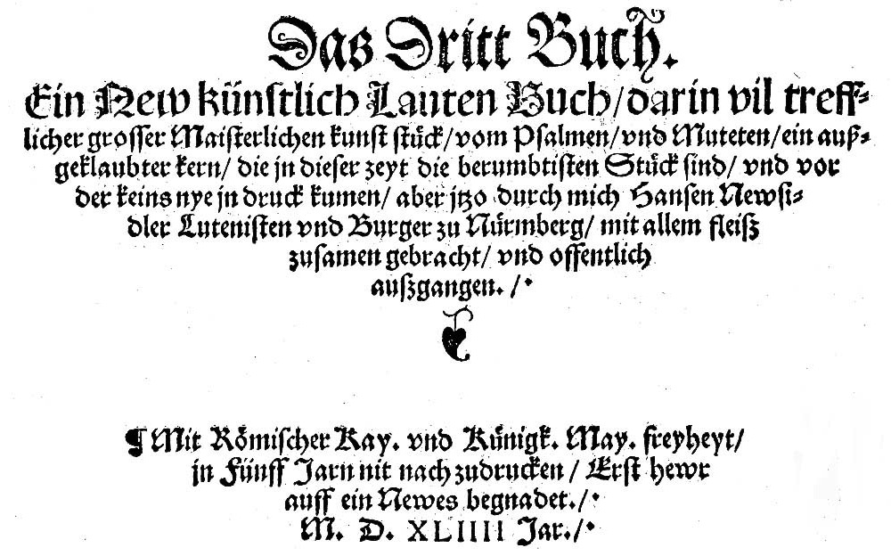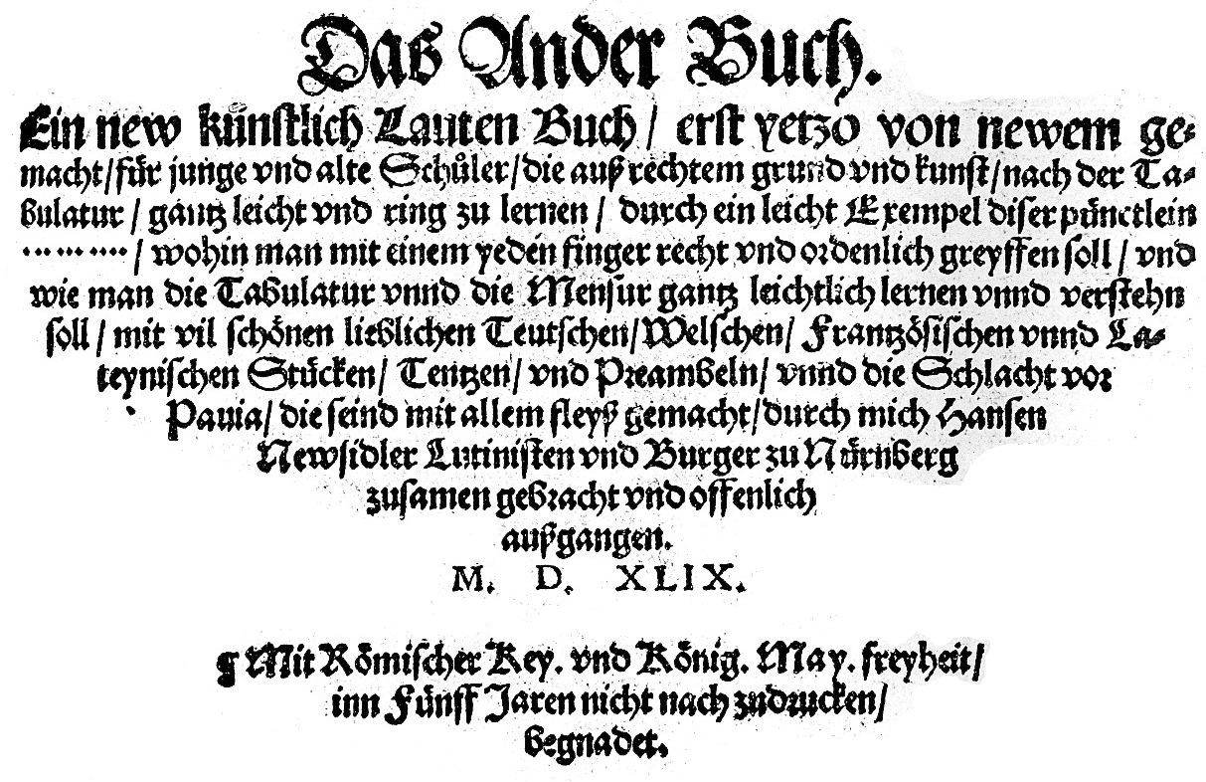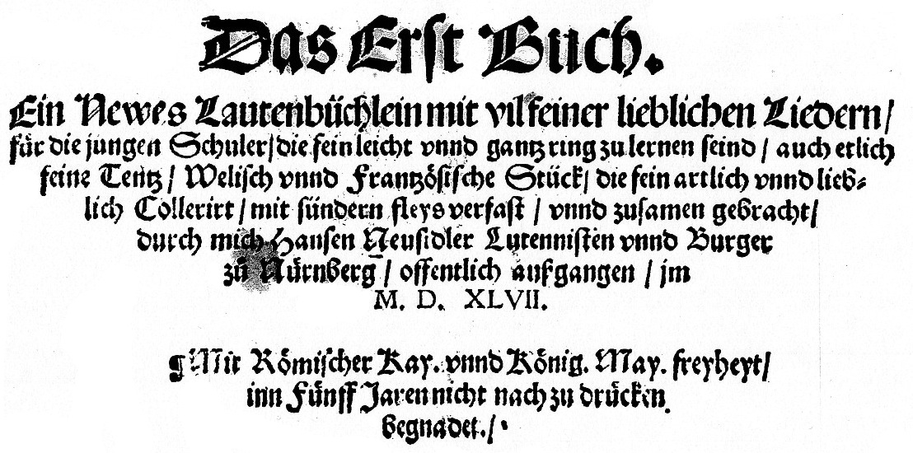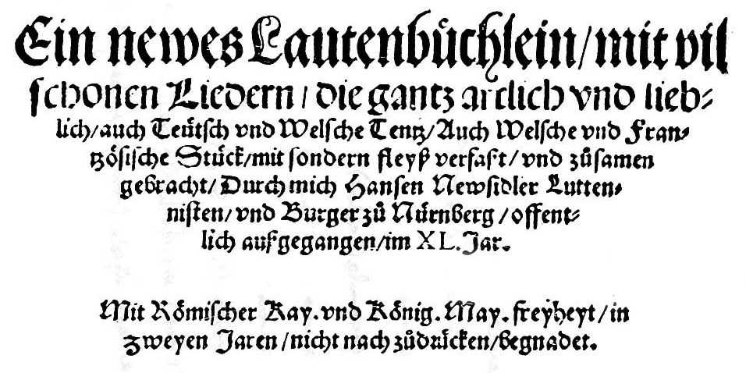

**Newsidler 1544a**

**Newsidler 1536b**

**Newsidler 1544b**

**Newsidler 1544c**

**Newsidler 1549**

**Newsidler 1547**

**Newsidler 1540**

**Newsidler 1536a**

1. Martin Shepherd (ed.) *Renaissance Lute Music from German Sources.* Modern edition, transcribed into French Tablature (Albury, The Lute Society, 2000) included Judenkünig no 1, 2, 4 & 5, and Newsidler 5-8 & 11a.
2. Judenkünig uses tenuto signs and hooked rhythm signs to indicate off beats to be plucked with left index finger - dot under tablature letter here. Gerle uses tenuto signs only in his first print. Newsidler uses tenuto signs, a dot above ciphers for right hand index finger, and in the fundaments right hand fingering is indicated with 1, 2, 3 or 4 dots for index, second, third and little finger respectively, but includes difficult fingerings suggestive of errors although reproduced here as in the original. He reproduces two versions of no 3 and 4, one with left hand fingering, the other with right hand fingering, combined into a single version here.
3. Commentary [recording what is in the original followed by what it is changed to]: **Hans Judenkünig**: **1.** none. **2.** 16/4 minim instead of crotchet. **3.** 12/1 f1 absent. **4.** none. **5.** 22/3 i4 instead of h4; 23/2 minim instead of semibreve. **Hans Gerle: 1.** 14/3 c5 under c2 a note to the right. **2a.**  none. **2b.** bar lines absent at 3-4, 6-7, 7-8, 13-14, 21-22, 22-23; 11/1 a6 probably an error for a5; bars 10-21 are the same as bars 17-28 of no 2a. **3.** bars 13/3 to 19/12 = 127/12, 40/3 to 46/8 = 134/9 to 143/8, 115/2 to 120/2 = 153/7 to 158/4129/1 to 132/8 = 176/1 to 179/8 = 214/1 to 219/9 of Newsidler no 12; 196/2 b3 absent. **4.** 2/12 f1 absent; 2/after 16 f2 inserted; 4/4 i2 instead of f2; 4/5-8 i3-g3-f3-h4 instead of h2-f2-h2-i2; 9/5 f1 absent; 9/after 12 f4 inserted. **5.** 13/2 d2d4f5 instead of d3d5f6; 43-44 bar line absent. **6a.** none. **6b.** bar lines absent at 10-11, 11-12; 11/4 d6 absent. **7.** 27-28 bar line absent. **8a.** 10/6-7 d5-c5 instead of c5-d5; 24/4 e3 instead of d2; 95/7 d1 instead of d3. **8b.** 58/1 d1 instead of c1. **9a.** 2/3 minim not dotted. **9b.** 13/1 b6 instead of e6; 39/3 d4 instead of d3; 43/1 c2 instead of c4. **Hans Newsidler**: **1.** none. **2.** 16/5 e1 instead of d2 on sig. c3r.. **3.** barring reconstructed editorially to reflect phrasing. **4.** none. **5.** barring reconstructed here to reflect phrasing; 7/1 minim c1d2d3a4 absent. **6.** none. **7a.** none. **7b.** none. **8.** 31/3 c3 instead of c1. **9.** none. **10.** none. **11a.** 22/1 minim absent. **11b.** none. **12.** 53/8 a1 instead of a2; 158/6-7 a2-b2 instead of a2-b2. **13.** none. **14.** none. **15.** 24/4-5 minim d2-c2 absent. **16.** none.
4. Two CDs include some of the Preambels here: Joachim Held *Nach Willen Dein* Alte Musik LC 11428 ORF CD 354 (2004), Judenkünig no 1 & 2, and Newsidler no 5, 7, 9 & 11; Bart Roose *Hans Neusidler Ein newgeordent künstlich Lautenbuch* Passacaille 945 (2007), Newsidler no 7, 9, 10, & 12 (track length 12 minutes 38 seconds!).
5. His two prints are *Utilis & compendiaria* (Wien, Hans Singriener?, *c.*1519) [no preludes]; and *Ain schone kunstliche* (Wien, Hans Singriener, 1523), and the five preambels are all found in the latter [title pages on p. 53]. Facsimile edition of both: Köln, Bernhard Becker, 1996. See Martha Blackman ‘A translation of Hans Judenkünig’s *Ain Schone Kunstliche Underweissung* ... 1523’ *Lute Society Journal* 14 (1972) 29-41.
6. Communicated by Martin Shepherd January 2009. All preludes in the prints of Pierre Phalèse were edited for Lute News 88 (December 2008).
7. His prints are *Musica Teusch* (Nürnberg, Hieronymus Formschneider, 1532 - facsimile: Stuttgart, Cornetto, 2012); *Tabulatur auff die Laudten* (Nürnberg, Hieronymus Formschneider, 1533); *Musica und Tabulatur* (Nürnberg, Hieronymus Formschneider, 1546 - facsimile, Genève, Minkoff, 1977); and *Eyn Newes sehr Künstliches Lautenbuch* (Nürnberg, Hieronymus Formschneider, 1552 - facsimile Stuttgart, Cornetto, 1997), see title pages on p. 53. Gerle 1552 includes 32 Preambels that are all fantasias and recercars from Italian lute books, and will be edited for a subsequent lutezine. See Jane Pierce ‘Hans Gerle: Sixteenth-century lutenist and pedagogue’ *JLSA* 6 (1973) 17-29.
8. Source abbreviations for Francesco da Milano prints as in Arthur J. Ness (ed.) *The Lute Music of Francesco Canova da Milano* (Harvard University Press, Cambridge MA, 1970).
9. Edited in Francesco series in *Lute News* 68 (December 2003).
10. Gordon Gregory (ed.) *Francesco da Milano Fantasias in British Manuscripts*. Tablature edition, (Albury, The Lute Society, 1998).
11. Edited in Francesco series in *Lute News* 67 (October 2003).
12. His prints are *Ein Newgeordent Künstliche Lautenbuch. Der erst* theil (Nürnberg, Johan Petreio, 1536a-facsimilies, Neuss, Junghanel-Päffgen-Schaffer, 1974 and Lübeck, Tree 2003), see Marc Southard and Suzana Cooper ‘A translation of Hans Newsidler’s Ein Newgeordent Künstlich Lautenbuch’ *JLSA* 11 (1978) 5-25; *Ein Newgeordent Künstliche Lautenbuch. Der ander theil des Lautenbuchs* (Nürnberg, Johan Petreio, 1536b- facsimile, Neuss, Junghanel-Päffgen-Schaffer, 1976); *Ein newes Lautenbüchlein* (Nürnberg: Hans Guldenmundt, 1540 [no preludes] - facsimile, Köln, Bernhard Christian Becker, 1996); *Das Erste Buch. Ein Newes Lautenbüchlein* (Nürnberg, Hans Günther, 1544a - modern tablature edition: Stewart McCoy, Harrow, Lute Society Music Editions, 1988); reprinted as *Das Erste Buch. Ein Newes Lautenbüchlein* (Nürnberg, Gutknecht, 1547); *Das Ander Buch. Ein New künstliche Lautten Buch* (Nürnberg, Hans Günther, 1544b)**;** revised as *Das Ander Buch. Ein New künstliche Lauten Buch* (Nürnberg, Julius Paulus Fabritius, 1549 **- f**acsimile, Stuttgart, Cornetto, 1997); and *Das Dritt Buch. Ein New künstlich Lautten Buch* (Nürnberg, Günther, 1544c - facsimile, Stuttgart, Cornetto, 1997) [no preludes], see title pages on p. 54.
13. Edited for Lute Society tablature sheet Series 8 no 1.
14. Corrections to the previous lutezine ‘Fantasias of Valentin Bakfark’: Fantasia 2: bar/position 81/5 f2 not f3; 124 crotchets not minims. Fantasia 5: 39/1 crotchet omitted. Fantasia 6: 45/7 d2d3 not d3d4.